COMMUNITY UPDATES

The DeerPointe Community has a new management company!

Our new Property manager is:

Nikki Kreger.
Phone: 720-880-291- Direct
Fax: 720-941-9202
Email: nikki@weststarmanagement.com
URL: www.weststarmanagement.com
Address: 6795 East Tennessee Ave. #601
Denver, CO 80244

Save the date for the Annual Homeowners meeting:

- Saturday November 4, 2017
- 10:30 a.m. to 12:30 p.m.
- Watch your mailbox for more details!
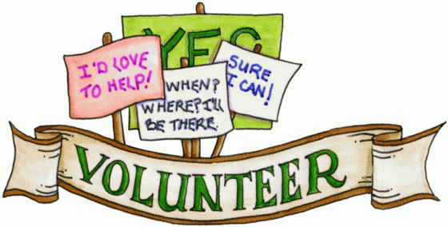

The DeerPointe Community has new Board members.

- Mark Beery President
- Catherine Johnson Vice President
- Karen Talley Treasurer
- Brittney Craigo Secretary
- Jennifer Prather Member At
Large

PARKING

The Board is analyzing ways to resolve the parking headaches you are experiencing.

In the meantime, please remember these rules:

- Garage parking is the privilege afforded to Homeowners.
- Garages are not to be used to store property.
- Outside parking must be approved by Board Members.
- All Homeowners must register vehicles, and receive indoor parking stickers.
- All Homeowners are responsible for ensuring their tenant’s vehicles are registered with the association, and have proper parking stickers.
- Property owners and residents are required to return stickers to management company after property is vacated.
- Homeowners will soon receive correspondence from our management company with forms to update parking information.

GET INVOLVED IN OUR HOA COMMUNITY!
REASONS TO BE INVOLVED IN YOUR COMMUNITY:

Strength in Numbers. Your tribe. How wonderful is it to meet people who care about the direction and shape of the community just like you? Chances are good things will come for all with like-minded people in the same room. Like the quote says, “If you want to go fast, go alone. If you want to go far, go together.”

Getting involved in your HOA is a great way to influence the policies and regulations of your community.

Problem Solving. Your involvement helps solve problems. For example, to create awareness of local traffic/speed issues, children safety, recent burglaries, etc. Your involvement will bring attention to any issues that need resolution that may require greater involvement from the Board, City or Law Enforcement.

A well-run Homeowner’s association, whose regulations are understood and respected within the community is a more attractive place to live, which means that property values remain more stable. A harmonious partnership between the Homeowners association and the residents adds to the quality of life which, after all, is the primary reason people move into community developments in the first place.

The best way to know what is going on within the community is to attend board meetings and to hold members accountable. As with any community, the best way to ensure that one's agenda is put forth is to be active within that community.

One way residents can help ensure that their homeowners associations (HOAs) set reasonable rules is to get involved themselves by joining their association board.

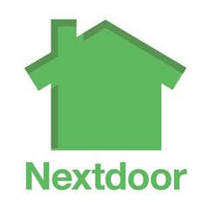
GET TO KNOW YOUR NEIGHBORS!
5 REASONS TO GET TO KNOW YOUR NEIGHBOR:

Safety. Information is power…when you are in-the-knowing, many adverse situations can be avoided. Meet a new neighbor or two and share what you know!

Fun. Are you a foodie? Love to taste new wines? Board game aficionado? The odds are some people in your community are just like you! Blow off some steam, de-stress and have some fun with those closest to you. Stepping out of your house and meeting others is a great way to be social and make new friends. Learning from others is what community is all about!

Learn Something. Although one may or may not want to share his/her secret juggling talents, sharing skills such as a handy man skill or even gardening skills can help others in the community. Get to know someone in your community and the chances are you can help EACH OTHER learn a new skill or two. What do you have to lose?

Awareness. Knowing who is who, and what is where is important in knowing your surroundings. Having awareness is key to knowing what changes are happening in your surroundings and what is acceptable vs. unacceptable.

Friendships. What better way to find new and fun friends than the people that are living within minutes of you. As the saying goes, friends are the family you choose.

REMINDERS

- Please remember to clean up after your pets!
It doesn’t count if your pet leaves gifts in your side yard, and you are not picking it up!
- Keep our grounds free of trash. This keeps our costs down.
- Report any suspicious behavior.

